System 9: The Rules
Rule One: Bet size
Each trade has a specific bet size. As the account balance changes so does the bet size. No more than five trades can be open at any one time. The bet sizes are noted as T1, T2 and so on. In the column “Max” that tells you the total amount of units allowed for all five trades.

“T1” is defined as number of units to trade divided by 14, The dividing number can be increased or decreased to adjust risk.

Below the bet size is shown in black (724, 723…)
ref: Goal

Rule Two: Spacing
Each trade has a number of points between one another. As long as that space between trades does not cross the EMA a trade can be opened.

The spacing are the red numbers.

Ref: Goal Sheet
Spacing Format A: 3 , 5 ,8 ,13
Spacing Format B: 8, 13
To define volatility as high or low, look at the ATR sheet. For values above 90, use spacing Format B
Ref: ATR Sheet

Rule Three: (EMA_BUY)
The price on the chart occurs above the EMA(34) for two or three candle periods
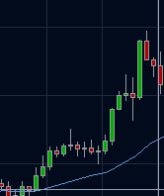

ref: Oanda FxTrade Client

Rule Four:(EMA_SELL)
The price on the chart occurs below the EMA(34) for two or three candle periods
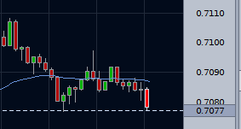

ref: Oanda FxTrade Client
Rule Five: Exit

Exit trade on one of the following:

If: Price crosses the EMA(34) in the other direction
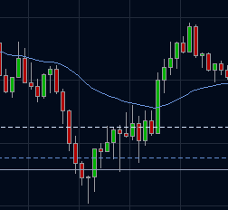

ref: Oanda FxTrade Client

Else: The price reaches profit goal.
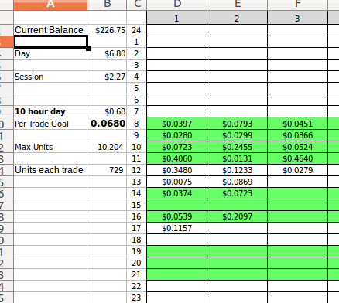

Ref: Setups Sheet

